Project China
4760 Ansley Lane
Cumming, GA 30040 678-701-5851 mark@projectchina.org
August 27, 2015
To Whom This Concerns:
I am privileged to know Josh Sullivan, who is my brother-in-law and recommend him for missionary service to South Africa. He has trained and served under his pastor at Fellowship Baptist Church in Maryville, TN for several years. He has also served as an intern in South Africa under veteran missionaries. Through the years Josh’s desire and call to ministry in South Africa has become evident.
I am looking forward to see how the Lord is going to use Josh and his family when they arrive in South Africa full-time.
If you have any questions or concerns about Josh and his ministry in South Africa, please feel free to contact me with the above contact information.

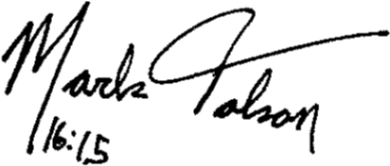
In His Joyful Service,

Mark Tolson

